Week 4 Final Assignment

Backend code: <https://github.com/subbuc7/finalassesment.git>

Backend code:

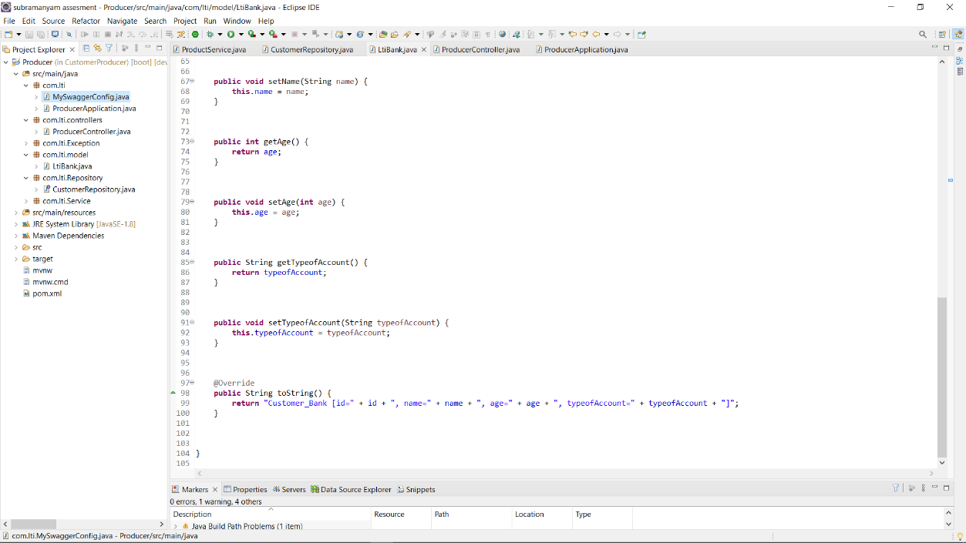

Front End : <https://github.com/subbuc7/finalassesment.git>

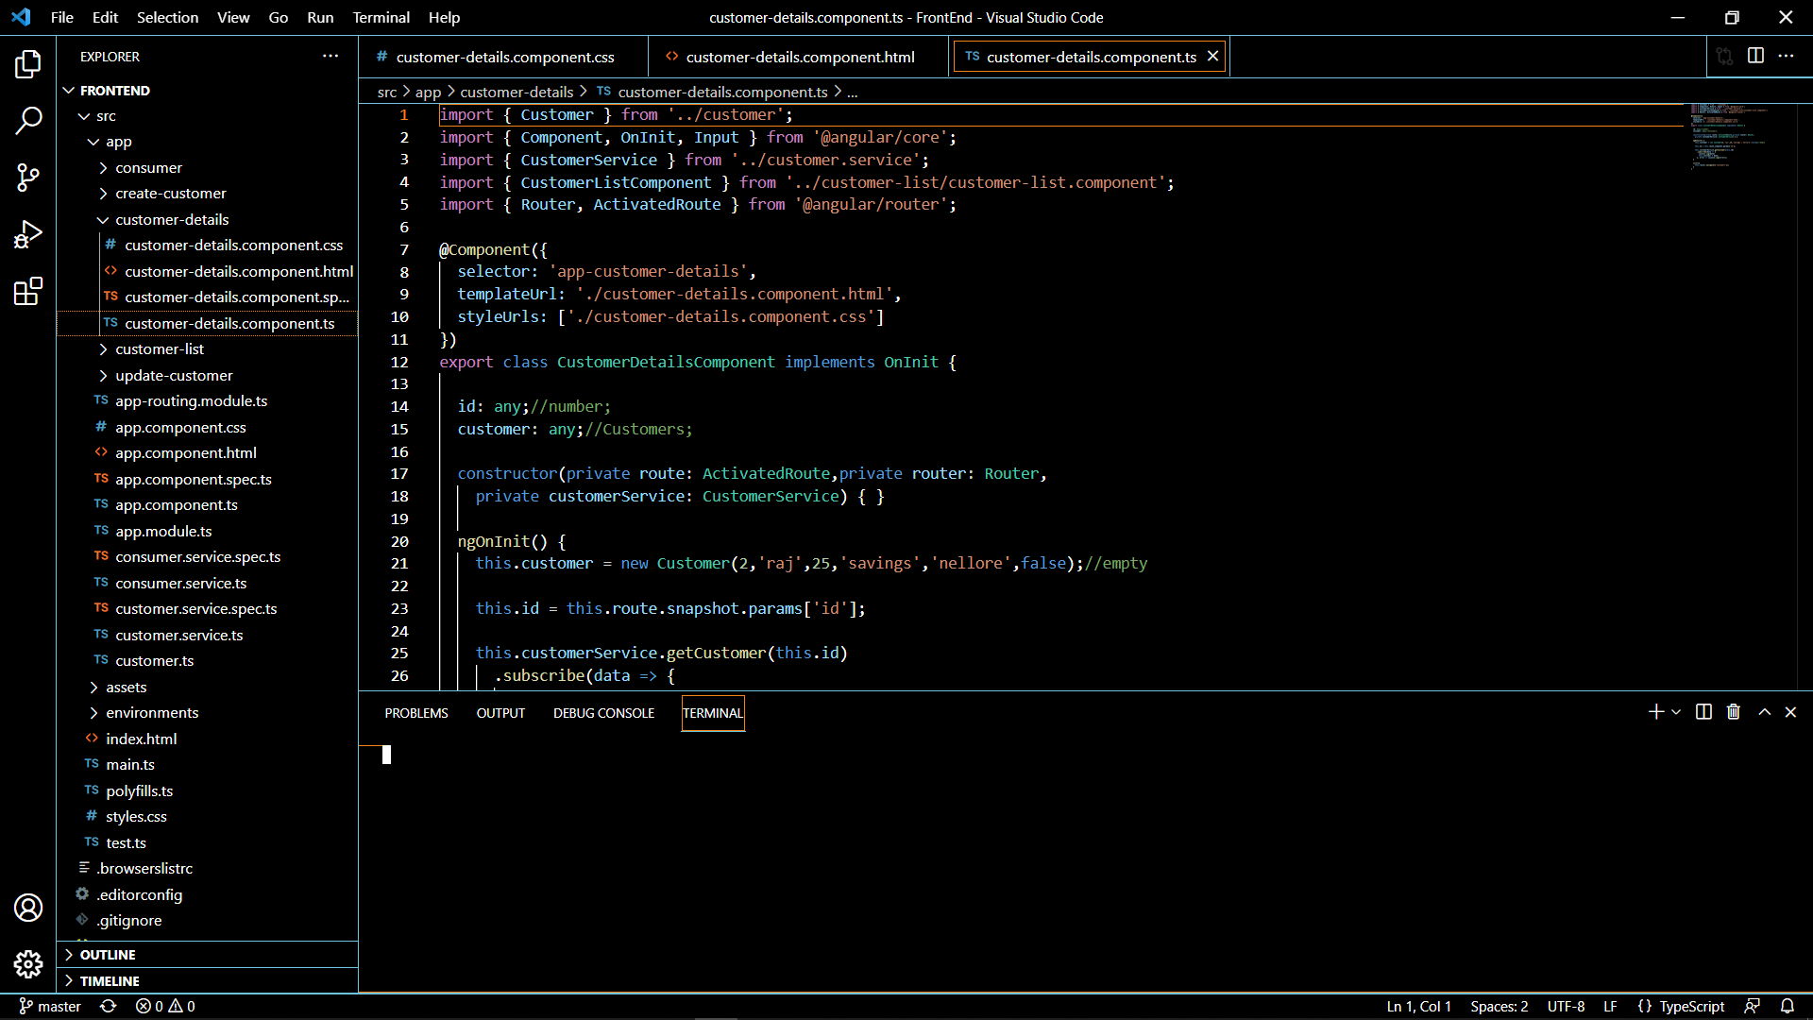

1) Push Eclipse code to git hub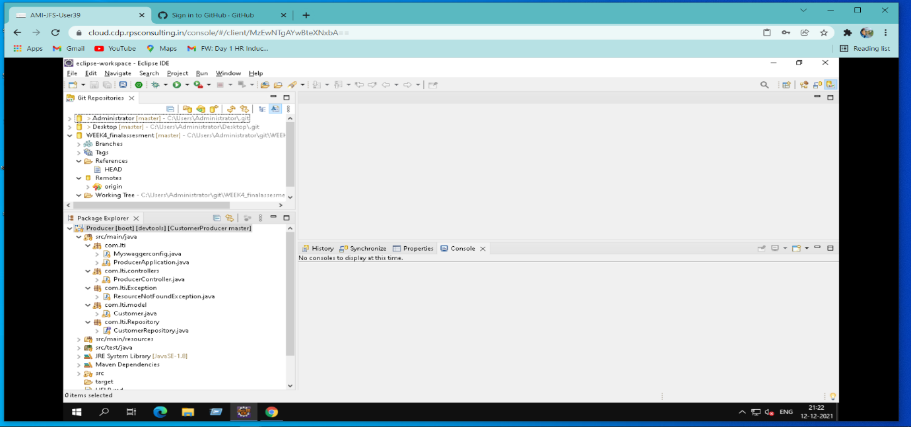

2)Push Frontend to git hub

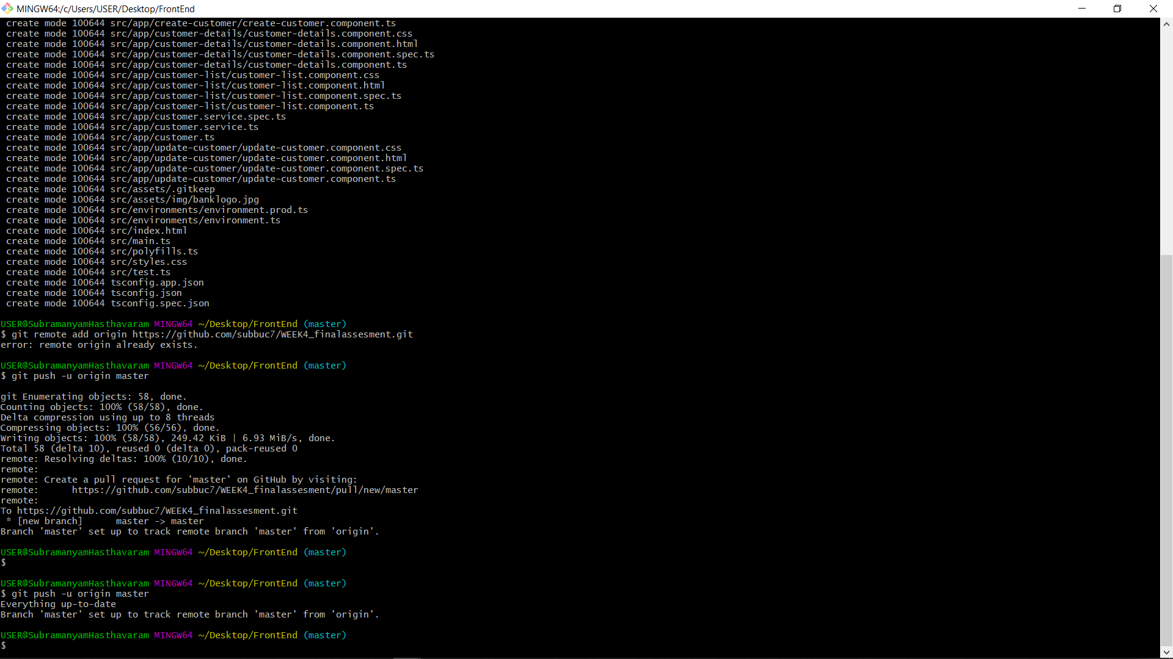

Github repositories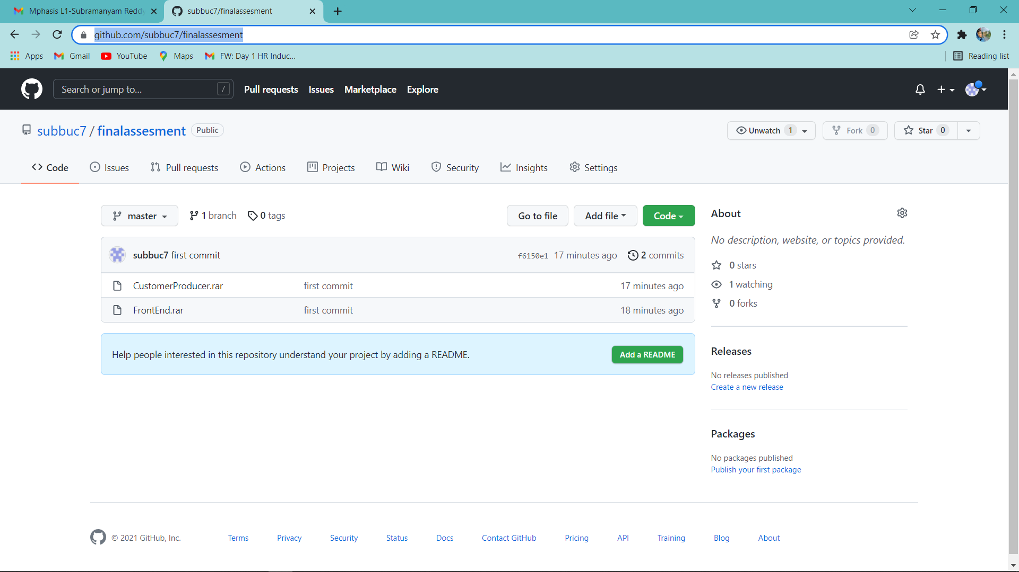

3)Junit testcases for producerController:

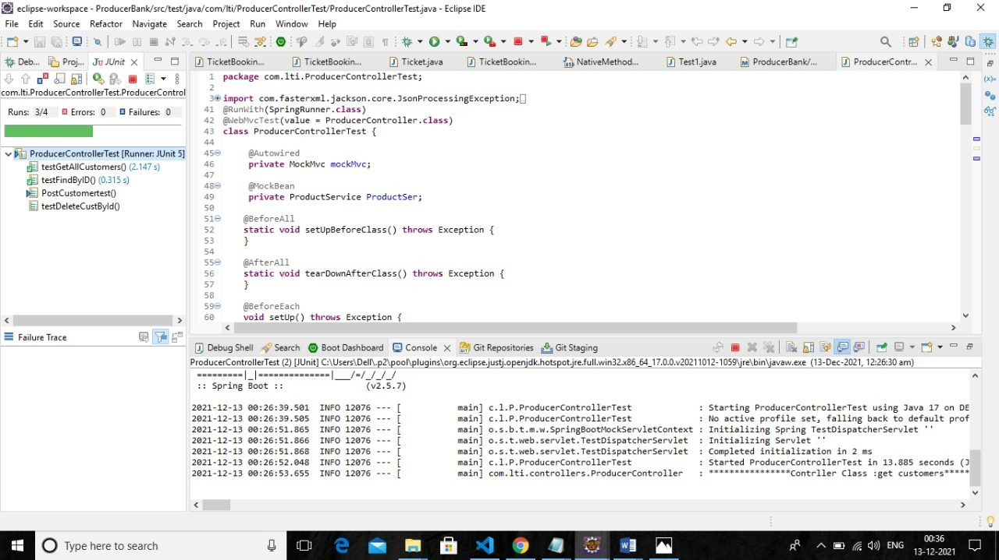

4) Code coverage: 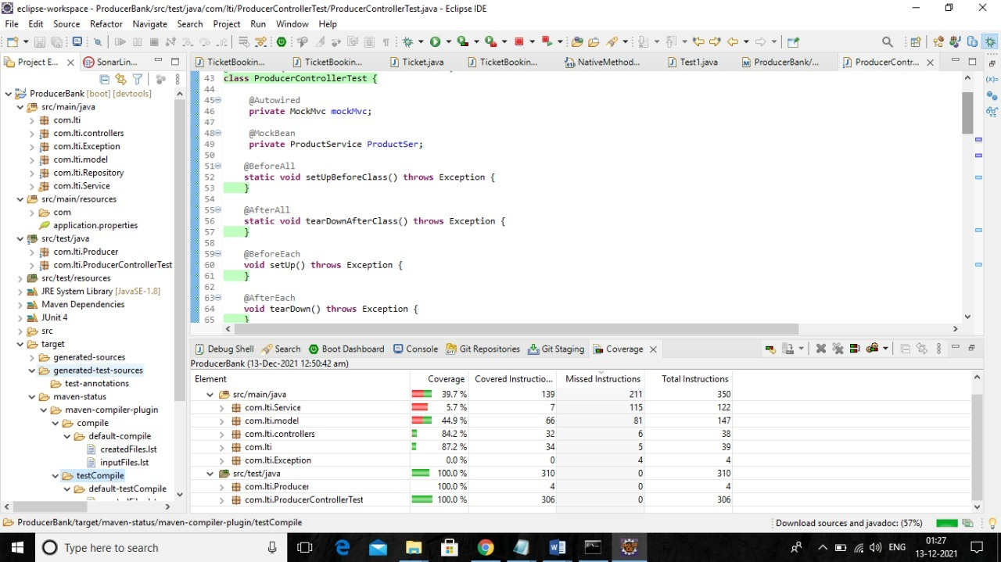

5)log4j for backend producer:

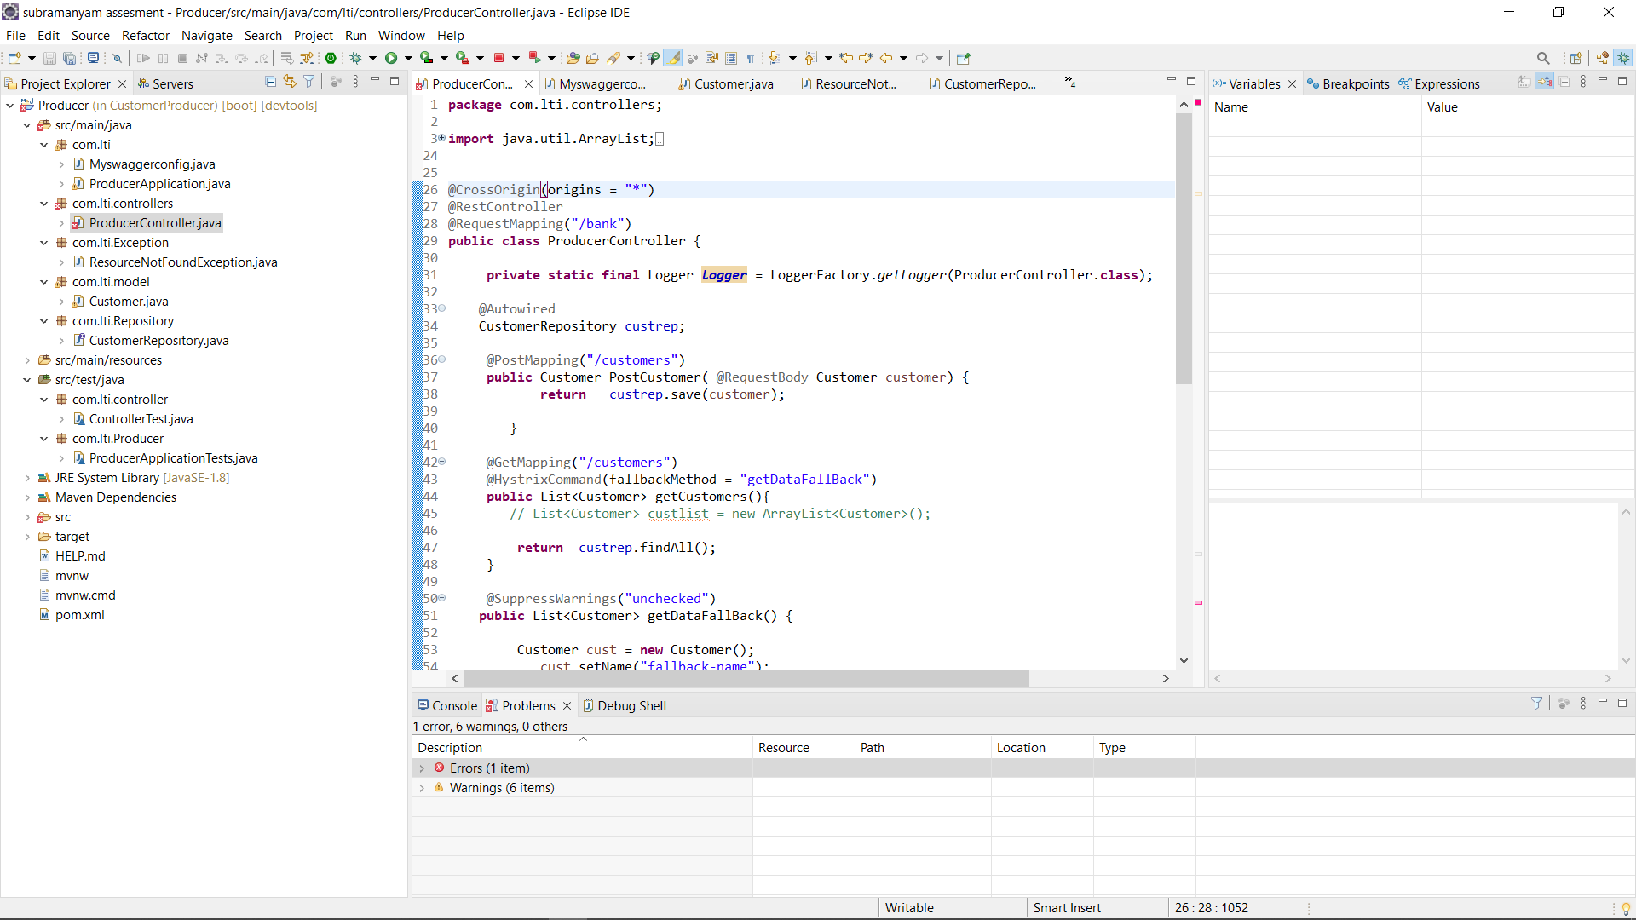

6)debug for producer:

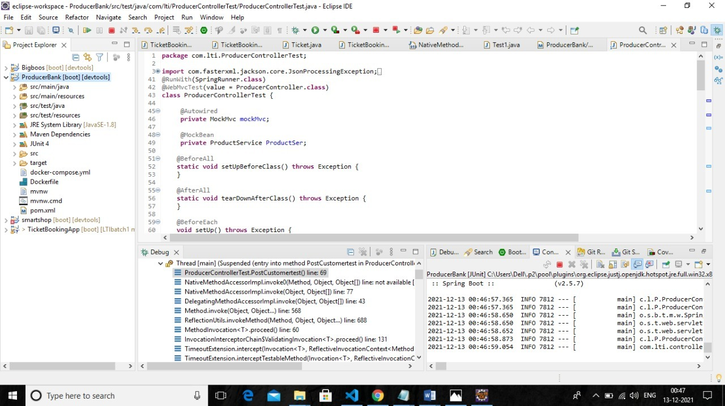

7)sonarlint for producer: 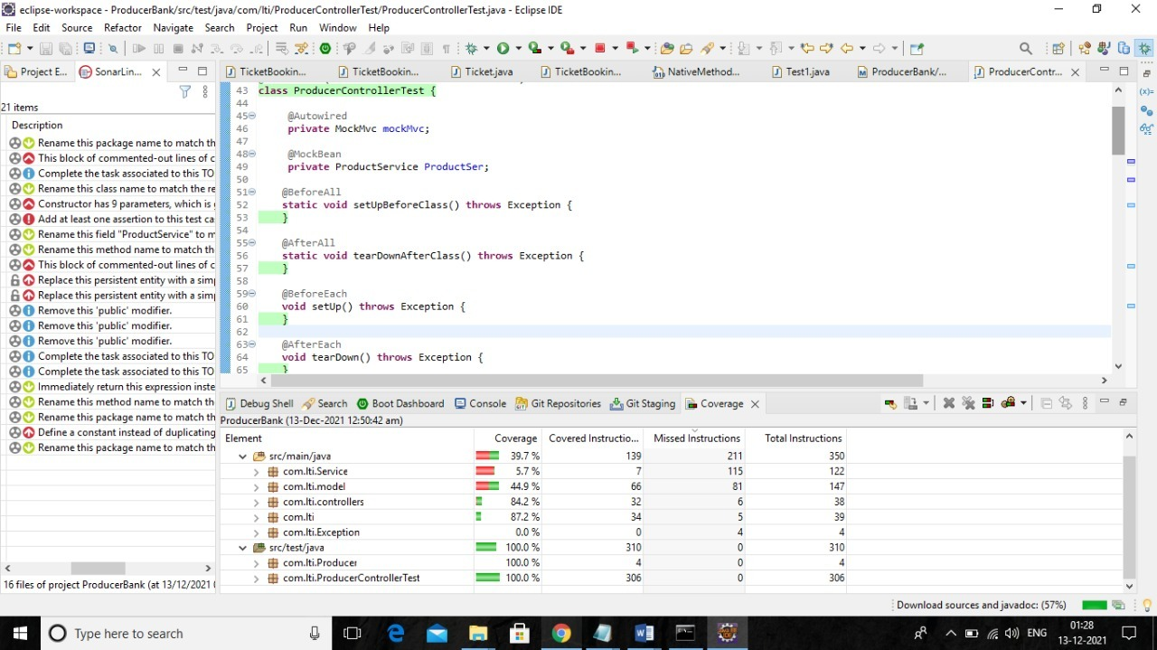

8)sonarqube for customer producer: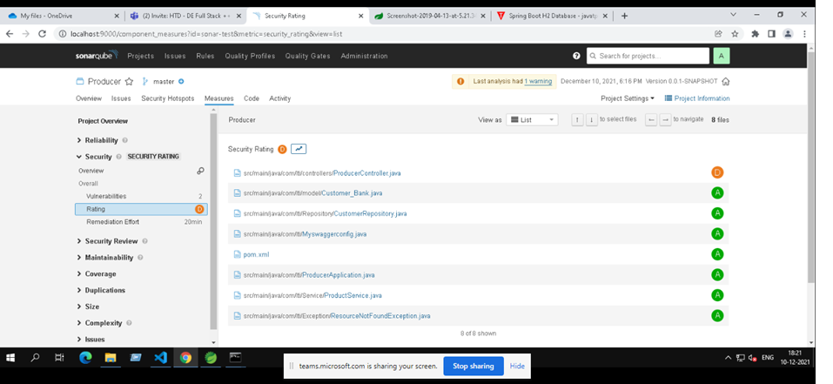

Bugs and vulnerabilities:

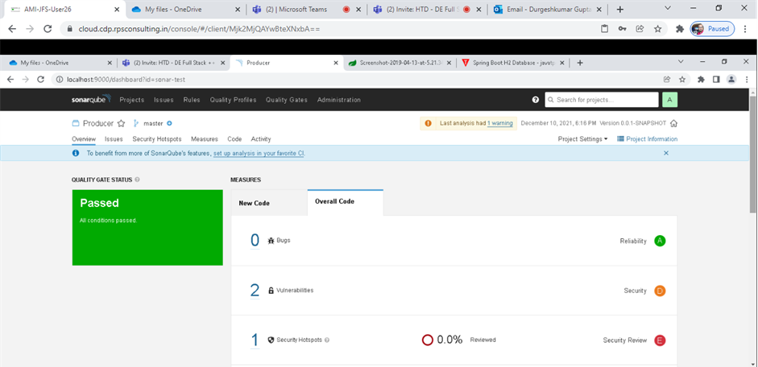

9)Maven build -mvn clen install:

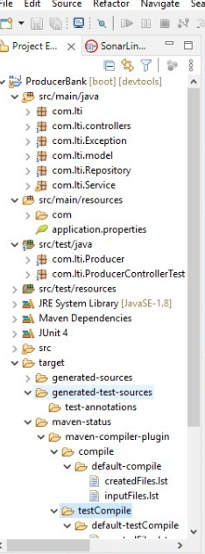

10)docker :

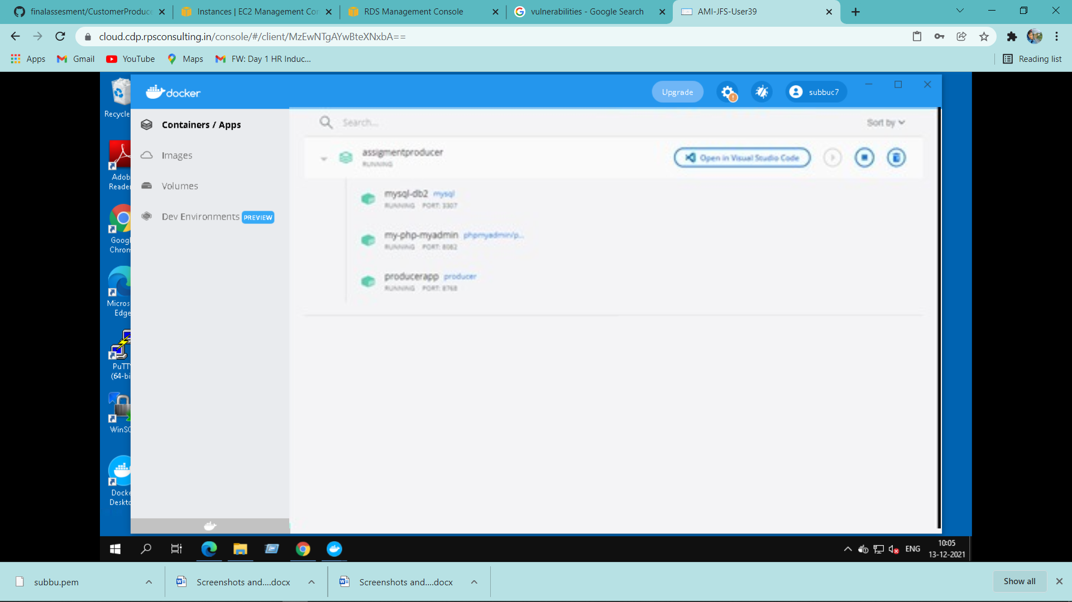

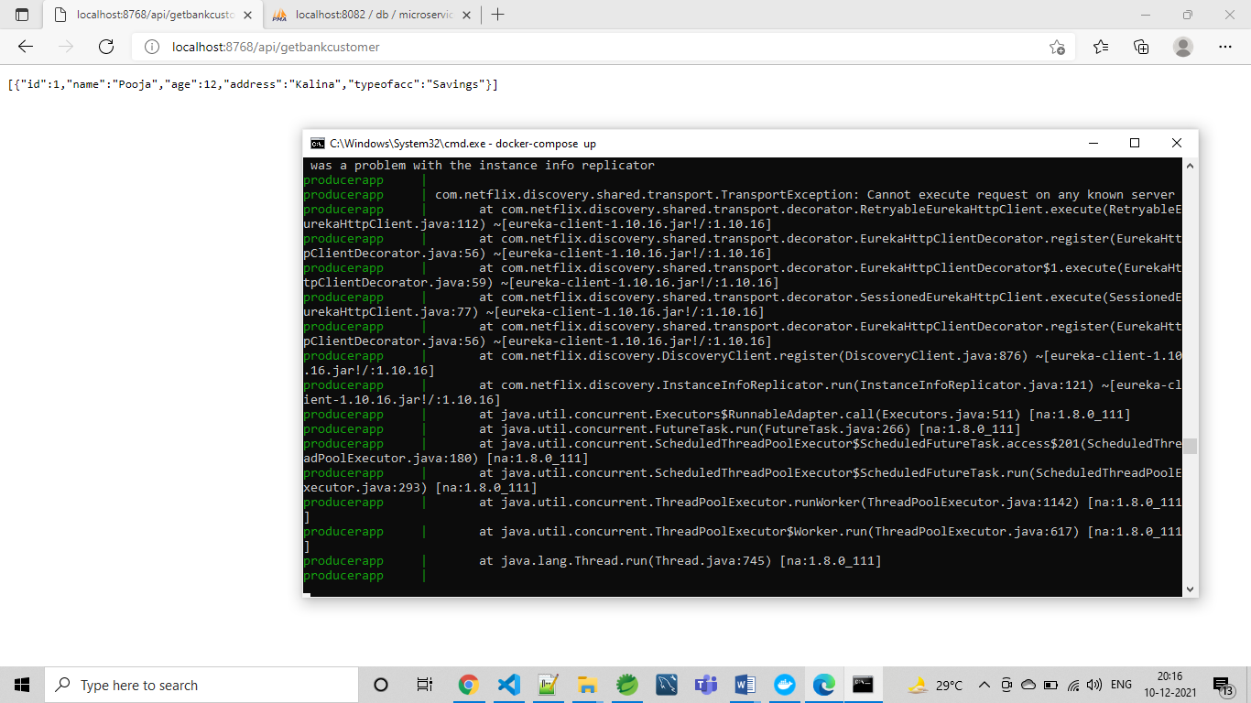

http://Localhost:4200/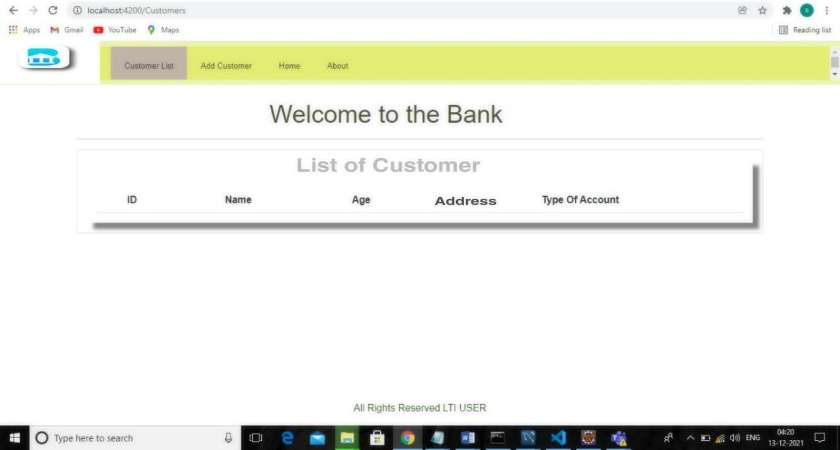

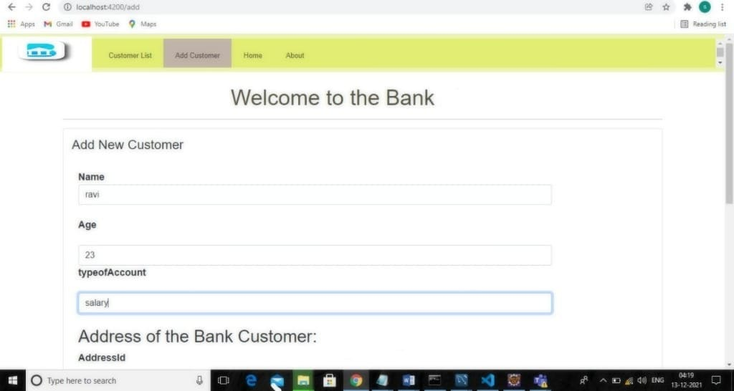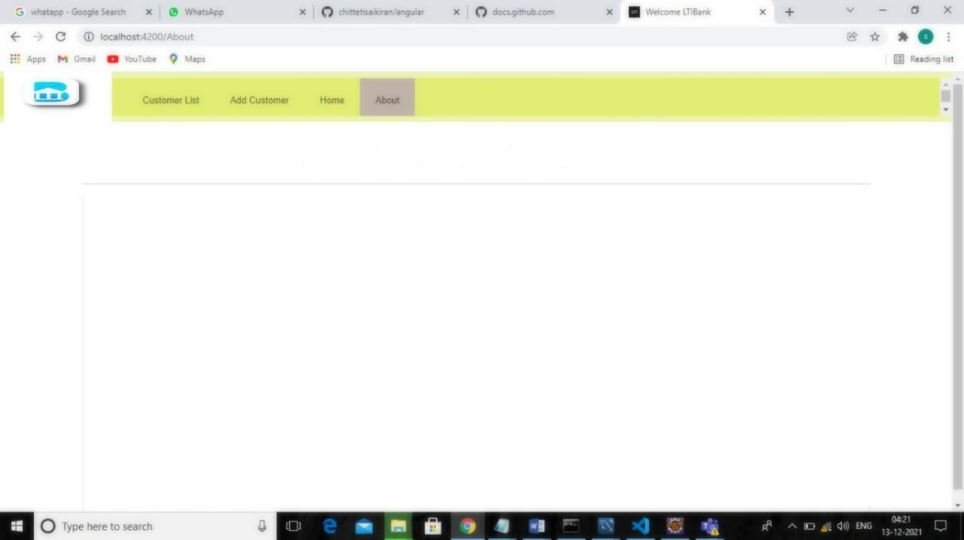

1)AWS:

1. Use S3 bucket to deploy Front end code – share URL and screenshots <url:s3://subbu4c7/FrontEnd/>

Screenshot: 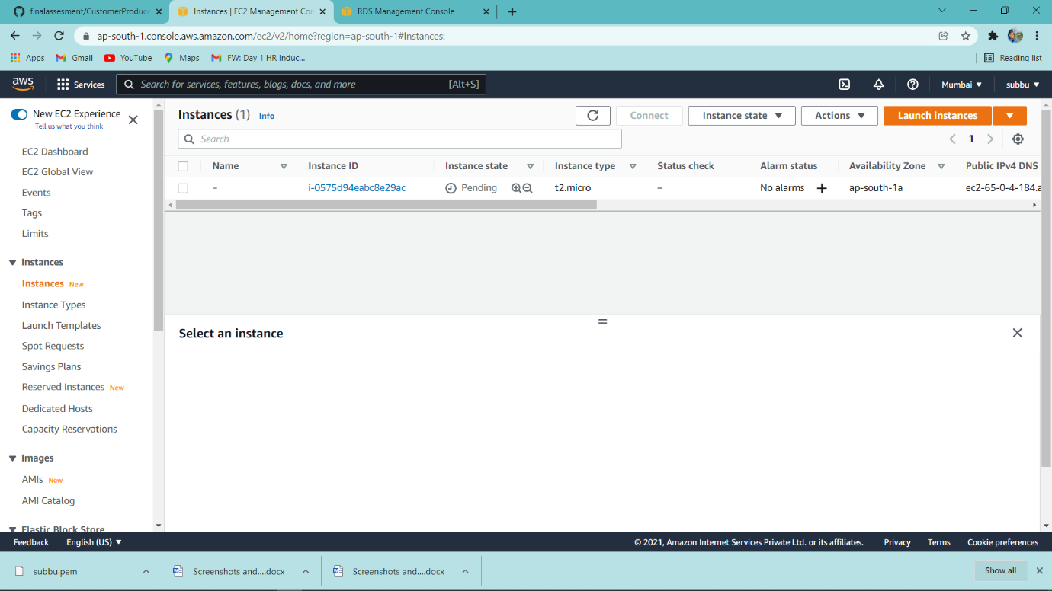

12)RDS Using instance to connect to MySQL instance.

database-1.clzauq0im3k3.ap-south-1.rds.amazonaws.com

port :3306

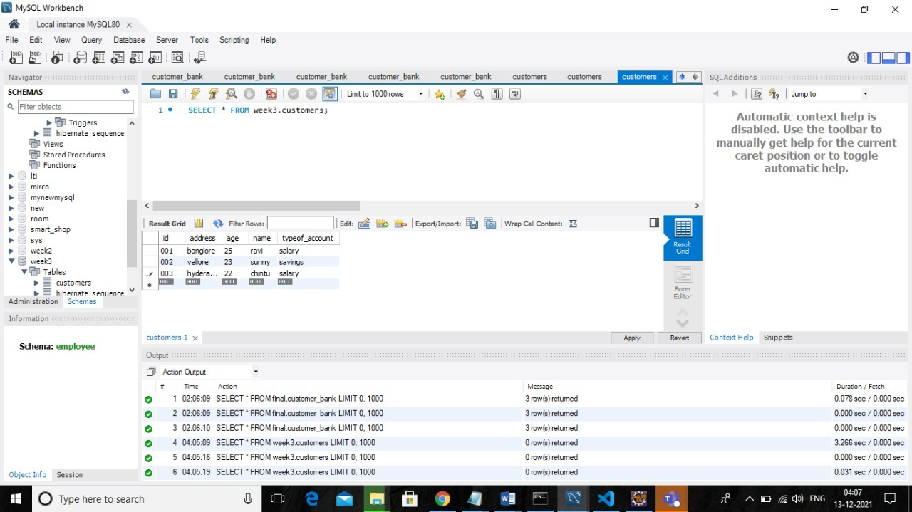

Screenshot:

